WELCOME TO KRAKOW
A PRACTICAL GUIDE

ARRIVING IN KRAKOW
- ARRIVING IN KRAKOW BY PLANE
You land at the John Paul II Krakow Airport (known as Balice Airport) which is located 17 km from the city centre.
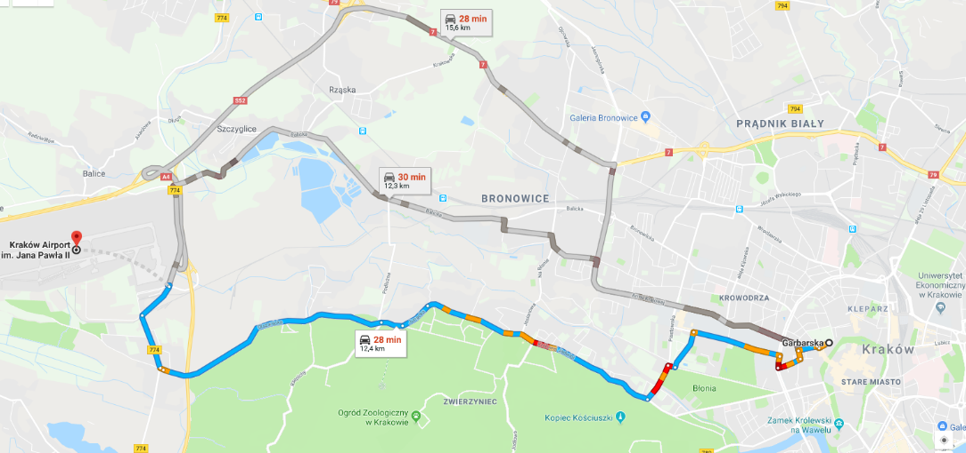
In order to get to the city centre, you can take a train, a bus or a taxi.
Online version of the map

From the airport by train
Train is the fastest way to reach the city centre (The Krakow Railway Station is called Dworzec Główny). Go from the terminal by a passageway to the railway station Kraków Airport.
The train runs twice an hour from 5am to 11pm and the journey lasts less than 18 min.
The ticket price is: 9 PLN.
Where to buy a ticket?
- passenger terminal, level 0 (ticket machine)
- railway station (ticket machine)
- the train (ticket machine or the train conductor on board)
Ticket machines accept payment both in cash and by payment cards.
The train schedule is available at: https://malopolskiekoleje.pl/

From the airport by bus
The cheaper but longer option is a public bus – the regular bus line 208 or 252 or one night line 902. When leaving the Terminal 1, you will find the bus stop on your right. The line no 208 leaves once an hour, whereas the line no 252 every 40 min.
Where to buy a ticket? At the ticket machines at the bus stop or on the bus.
What’s the ticket price? 5 PLN – multiple-trip ticket for min 60 min to get to the city centre.
How to pay? The ticket machines at the bus stop and on the bus accept cash and a card. You can ask the bus driver for a ticket only if the ticket machine is out of order (the bus driver only accepts the exact amount in cash).
The ticket must be validated immediately when getting on the bus.
The bus/tram timetable is available at: http://rozklady.mpk.krakow.pl/
You can find the best /tram connection at: https://jakdojade.pl/krakow/trasa/

From the airport by taxi
The airport provides its own Krakow Airport Taxi service with cars waiting outside the terminal entrances. The cost is around 69 – 89 PLN. The fares depend on the duration of the ride, time of day and day of the week. You can pay in cash or use a payment card.

- ARRIVING IN KRAKOW BY TRAIN
The Main Railway Station and Main Bus Station are situated in the city centre, 15 min from the Main Town Square on foot.

- ARRIVING IN KRAKOW BY CAR
You won’t have any difficlty getting to Krakow by car as the roads in Poland are well sign-posted. You can find paid parking areas in almost every part of the city centre. Please note that the traffic jams are common, particularly during rush hours.
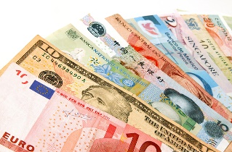

CURRENCY
The official currency of Poland is 1 złoty (zł, PLN) = 100 groszy (gr).
Currency exchange points can be found at the airport, in the city centre, at the railway station and in some hotels.

ELECTRICITY
For Poland there are two associated plug types, types C and E (see the pictures below). Plug type C is the plug which has two round pins and plug type E is the plug which has two round pins and a hole for the socket’s male earthing pin.
Poland operates on a 230V supply voltage and 50Hz.

GENERAL FACTS ABOUT POLAND

Official name: Republic of Poland, short form: Poland (in Polish: Rzeczpospolita Polska; Polska)
Location: central Europe, bordered by Germany to the west, Czech Republic and Slovakia to the south, Ukraine, Belarus, Lithuania to the east and the Russia’s territory and the Baltic Sea to the north
Capital city: Warsaw (in Polish: Warszawa)
Major cities: Kraków, Łódź, Wrocław, Gdańsk, Szczecin, Bydgoszcz, Lublin, Katowice, Białystok)
Area: 312 685 km²; Poland is the ninth largest country in Europe
Official language: Polish
Political system: Parliamentary Republic (multi-party democracy with a two-chamber parliament and a president)
Population: 38 million
Religion: about 90 % of Poles are Roman Catholics
Currency: 1 złoty (PLN) = 100 groszy
Time zone: Central European (GMT + 1hour / UTC + 1 hour)
Dialling code: +48
Average winter temperature: 0 to -10°C /- 20°C
Average summer temperature: 21 to 33°C

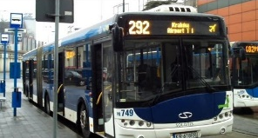
PUBLIC TRANSPORT IN KRAKOW
Krakow boasts well-developed public transport. To find the best connection, go to https://jakdojade.pl/krakow/trasa/ or download a jakdojade app to your smartphone.
If you’re planning to change buses/trams, you can buy a time ticket (e.g. 40 min). The ticket is valid for 40 min starting the moment you validate it. Otherwise, you can buy a single-fare ticket.
If you’re staying in Krakow for more than 1 month and planning to use public transport often, it is worth purchasing a 1-month ticket (season ticket). All types of season tickets are sold at the sales points of Municipal Transport Company.
The bus/tram timetable is available at: http://rozklady.mpk.krakow.pl/
Other useful information at: http://www.mpk.krakow.pl/en/prices-of-tickets/

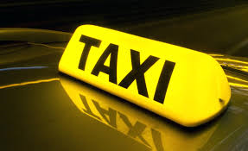
TAXI SERVICE IN KRAKOW
iCar, tel. 12 653 55 55, 12 888 00 00, icartaxi.eu
Barbakan, tel. 196 61, 609 400 400, www.taxi.barbakan.krakow.pl
Radio Taxi 919, tel. 191 91, 12 419 00 00, radiotaxi919.pl
Dwójki, tel. 196 22, 12 422 22 22, www.taxi.krakow.pl
Mega, tel. 196 25, 12 400 00 00, megataxi.pl
Wawel, tel. 196 66, 12 266 66 66, waweltaxi.pl

WHAT TO SEE IN KRAKOW

EXPLORE THE CITY CENTRE
The centre of Krakow can be divided into two main sections – the Old Town and Kazimierz (the former Jewish Quarter), with Wawel (the former Royal Castle, nowadays museum) towering between them. The Old Town is home to the most popular monuments in Krakow starting with Rynek Główny – the largest medieval market square in Central Europe. The whole Old Town area is surrounded by the green line called Planty. You can also find here the second largest University in central Europe – Jagiellonian University. The oldest building which serves now as a museum is Collegium Maius. Moreover, the Jewish heritage trail naturally leads you from Kazimierz to Podgórze - the city’s most evocative and mysterious district.
ENJOY THE NATURE
Krakow’s greenest area is Salwator located west of the Old Town where you can enjoy the view of the city and its surroundings thanks to a unique outdoor attraction Kosciuszko Mound. If you would like to have a walk, head to Błonia – the biggest city-centre meadow in Europe. Other areas that provide plenty of hiking opportunities are Las Wolski (Wolski Forest) and the Zoo. It is also worth exploring Nowa Huta, which is one of the only two planned socialist realist cities ever built.
GO AWAY AT THE WEEKEND
If you’re interested in exploring the area during the weekend, consider visiting Wieliczka Salt Mine, Tyniec and Ojców National Park as well as Aushwitz-Birkenau. The location of Krakow in southern Poland gives you the opportunity to go on a trip to the Beskidy and Tatra mountains. Zakopane is a popular destination for skiing in winter and hiking in summer.
GO SHOPPING
While Kraków cannot be considered a shoppers' paradise in the traditional sense, its artsy reputation makes it a great place to pick up antiques, artwork and jewellery. It is worth visiting Kazimierz and the open air markets, especially Plac Targowy. For typical Cracovian souvenirs head to the Cloth Hall in the centre of the main square. There are also several grand shopping malls around the city.
VISIT MUSEUMS
The most popular museums in Krakowa are the National Museum and Shindler’s Factory dedicated to Oscar Schindler and his employees. Old Synagogue (no longer a working synagogue) serves as the oldest surviving example of Jewish religious architecture in Poland and is home to the history and traditions of Polish Judaism. Rynek Underground takes you 4 metres under the Surface of the market square to explore the medieval merchant stalls that predate today’s Cloth Hall.

KEY CONTACTS

DEPARTMENT | CONTACT | INFORMATION
International Visitors’ Office | ul. Czapskich 4, 31-113 Kraków  +48 12 663 38 50  http://www.international.iro.uj.edu.pl/ | contact the department regarding information, advice and suport in preperation for and during your stay in Krakow.
Office of Human Resources | ul. Straszewskiego 27, 31-110 Kraków  +48 12 663 11 10  maria.jania@uj.edu.pl
International Relations Office | ul. Czapskich 4, 31-110 Kraków  +48 12 663 11 10  http://www.dwm.uj.edu.pl/en_GB/o-dziale2
Centre for Project Administrative Support | ul. Czapskich 4, 31-110 Kraków  +48 12 663 38 33  dorota.buchwald@uj.edu.pl  http://www.cawp.uj.edu.pl/en_GB/

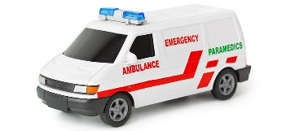
EMERGENCY NUMBERS
European emergency line: 112 (equivalent to U.S. 911)
The European emergency phone numer is available everywhere in the EU, free of charge. You can call 112 from fixed and mobile phones to contact any emergency service: an ambulance, the fire brigade or the police.
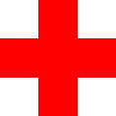
Medical emergency service: 999 Police: 997 Fire brigade: 998
HOSPITALS IN KRAKOW
Emergency Departments in Poland are called Szpitalny Oddział Ratunkowy
or SOR for short.

Szpital Uniwersytecki w Krakowie (The University Hospital in Krakow)
GENERAL HOSPITAL – 1st OPTION IN CASE OF EMERGENCY
Address: 31-501 Krakow, ul. Kopernika 50
Phone: +48 12 424 70 00

Szpital im. Gabriela Narutowicza
Address: ul. Prądnicka 35-37
Phone: +48 12 416 22 66
Wojskowy Szpital Kliniczny
Address: ul. Wrocławska 1-3
Phone: +48 12 630 81 62

Szpital im. Ludwika Rydygiera
Address: os. Złotej Jesieni 1
Phone: +48 12 646 80 00

SOCIAL LIFE IN KRAKOW
Krakow is home to hundreds of bars, cafes and restaurants. The main streets for clubbing are Floriańska and Szewska.
http://www.krakow.pl/english/culture/6501,events.html
USEFUL LINKS
Information about Krakow
http://www.cracowonline.com/
Information about Poland
https://www.euraxess.pl/poland/information-assistance/about-poland
Information about research in Poland
https://www.euraxess.pl/poland/research-poland-0

